Phase 2.1 Overall Plan

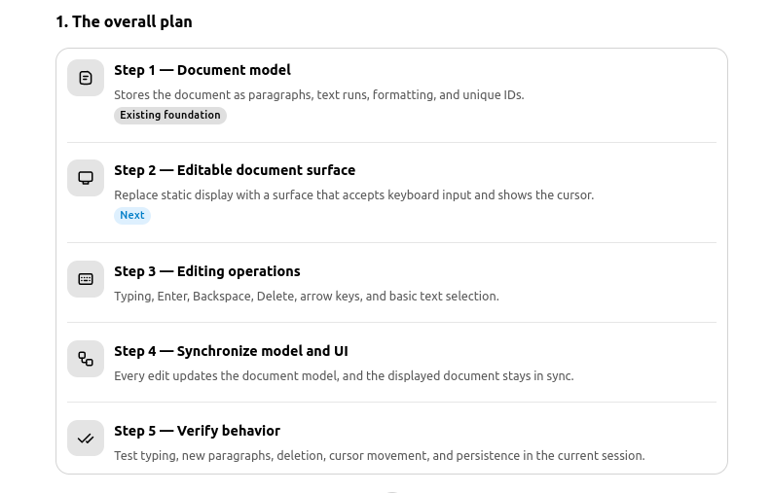

Phase 2.1 – Basic Document Editor: Initial Document Rendering Engine
Implemented the initial document model and rendering components to display structured text, including paragraphs and text formatting, within the A4 document workspace.

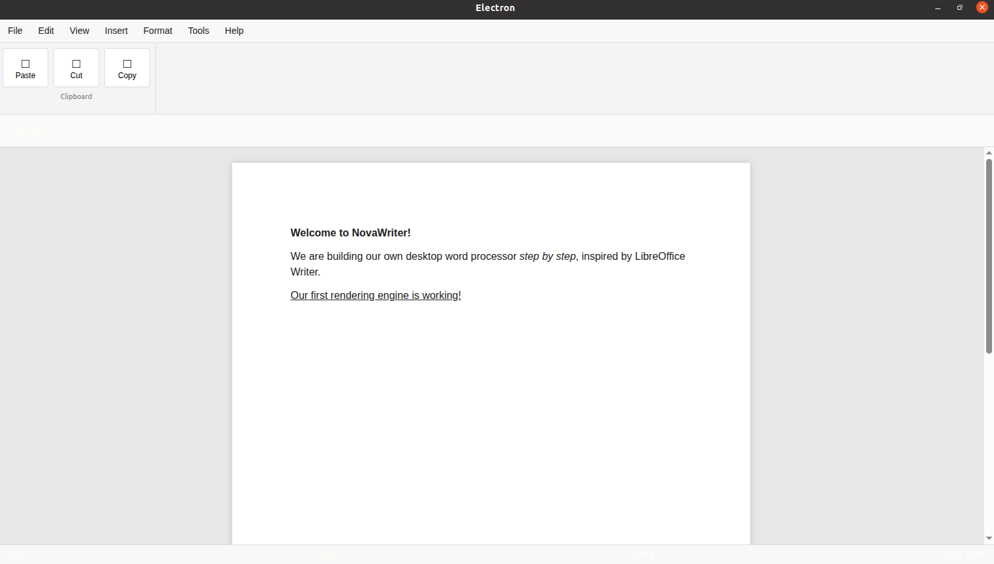

Next plan
2. Architecture map — how the parts connect
This is the architecture I recommend for NovaWriter's first editing milestone.
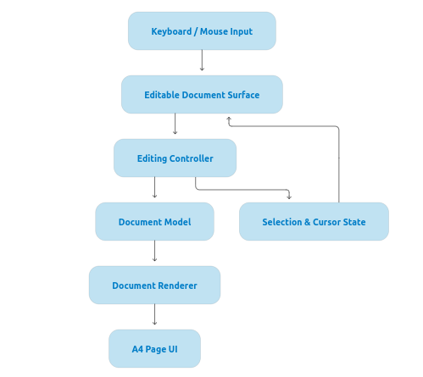

We are planning to use prosemirror.
Brief about prosemirror:
I recommend Tiptap, which is built on ProseMirror. It provides core editing behavior

Phase 2.2 – Editing Engine Selection: Tiptap and ProseMirror
Tiptap: A headless rich-text editor framework that provides editable text, cursor movement, selection, and formatting, with React integration.
ProseMirror: The underlying editor toolkit that powers Tiptap, providing the document model, editing transactions, selection management, and extensible editing behavior.
Decision: NovaWriter will use Tiptap for the editing experience and ProseMirror as its underlying editing engine, allowing us to build custom UI and add advanced word-processing features over time.
